MEASURING SUCCESS IN TALENT MANAGEMENT

1. INTRODUCTION:

1.1.OVERVIEW:

Talent management is how employers recruit and develop a workspace that is as productive as possible and likely to stay with their organization long term. When implemented strategically, this process can help improve the overall performance of the business and ensure that it remains competitive.

1.2. PURPOSE:

To measure success effectively, it’s crucial to identity and track relevant Key Performance Indicators (KPIs) for each aspect of talent management. KPIs could include metrics such as employee turnover rates, time-to-fill positions, training completion rates,and employee satisfaction scores.

1. PROBLEM DEFINITION & DESIGN THINKING:

2.1.EMPATHY MAP:

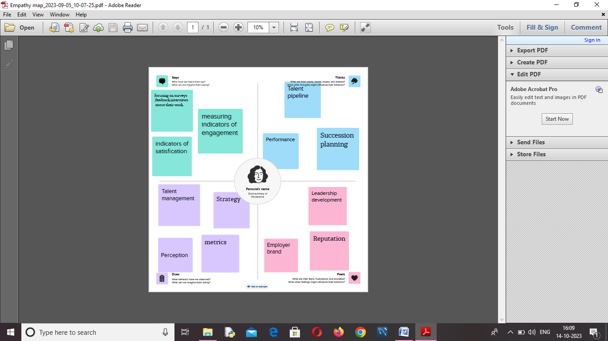

2.2.BRAIN STORMING & IDEA PRIORITIZATION:

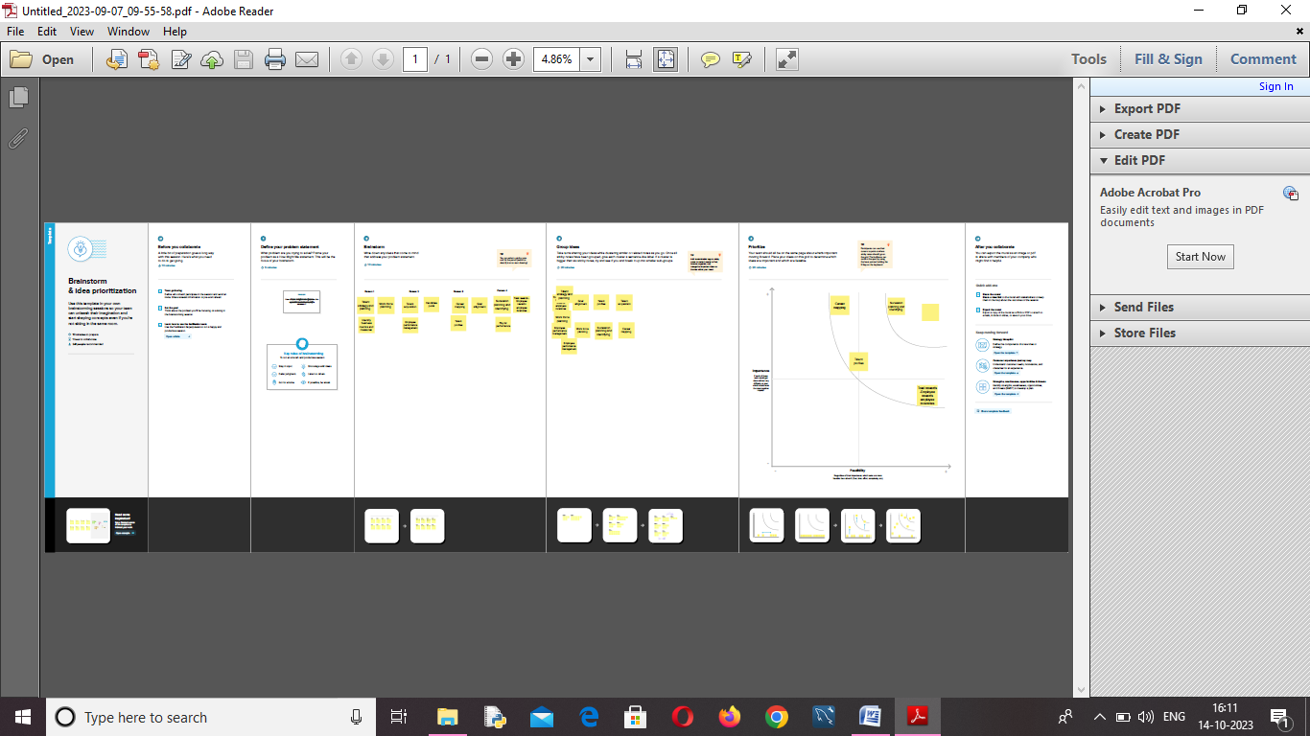

1. RESULT:

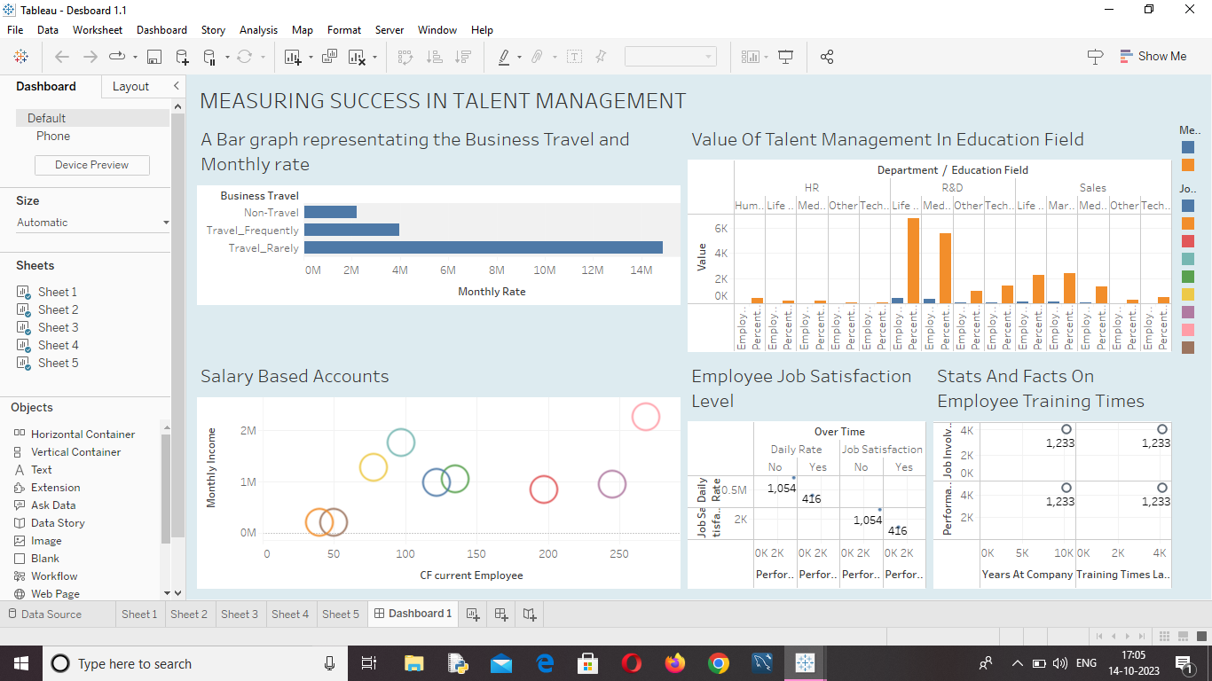

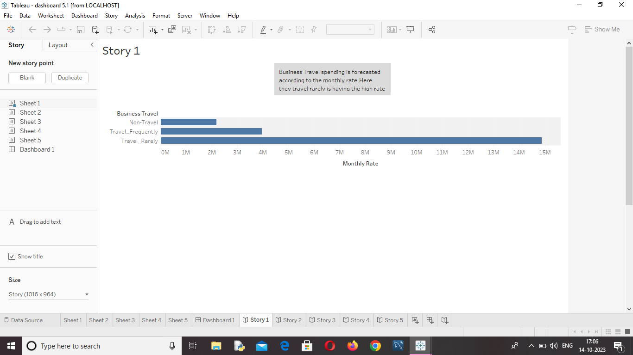

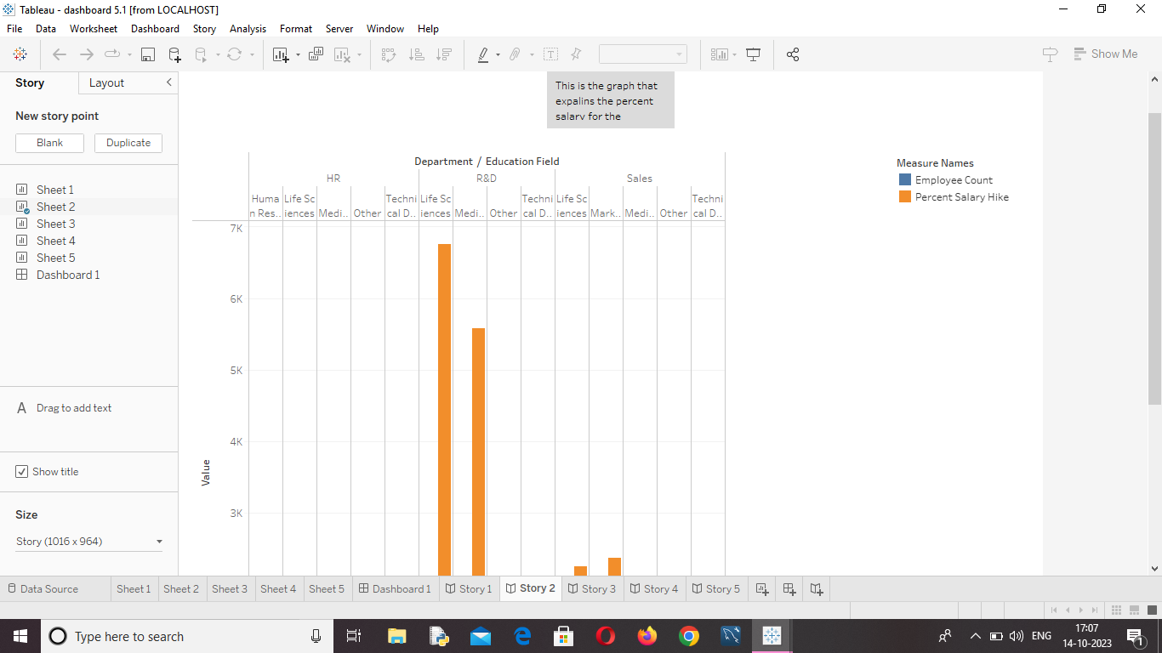

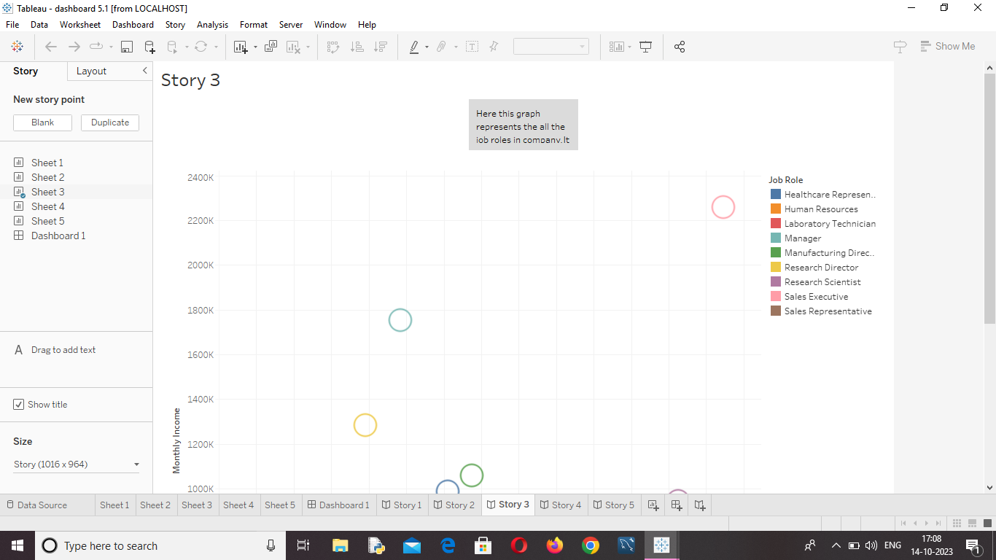

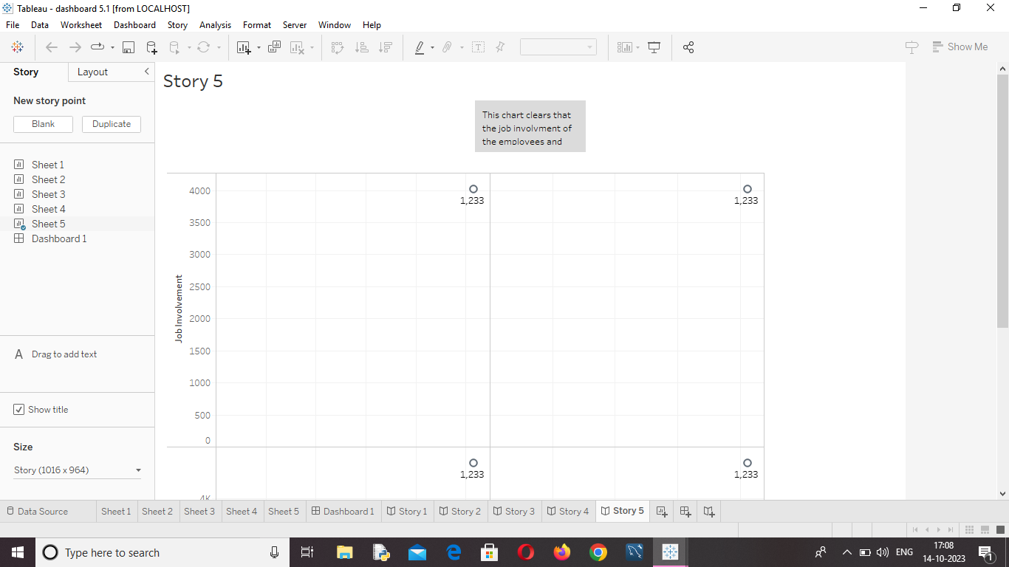

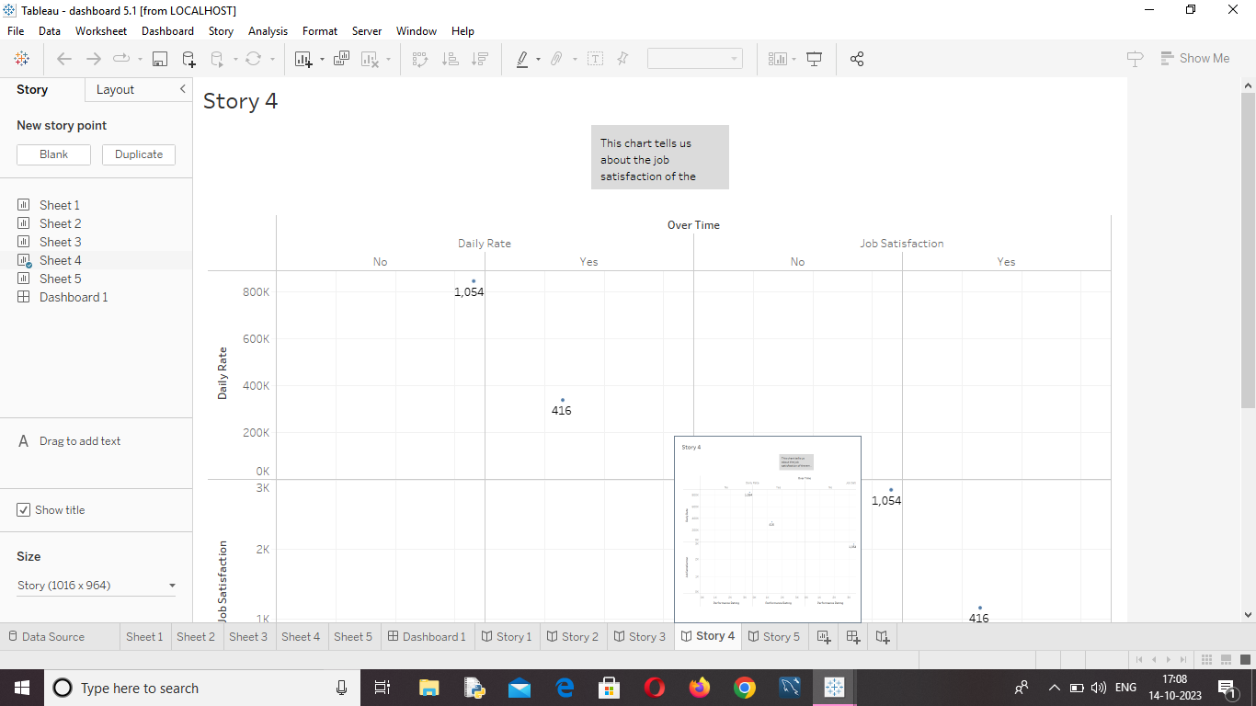



4.ADVANTAGE & DISADVANTAGE:

ADVANTAGE:

* Help in ascertaining the right person is deployed in the right position.
* Contributes in retaining their top talent.
* Better hiring by hiring assessments.
* Helps in understanding employees better and shaping their future.
* Reducing Recruitment costs.

DISADVANTAGE:

* Difficulty in implementation.
* Resistance to change.
* Lack of Numerical Metrics.

5. APPLICATIONS:

* A Talent Management System (TMS) is an integrated software platform that supports the entire employee lifecycle, from acquisition through succession planning. Explore TMS solutions.
* Selecting appropriate metrics for measurement.

6. CONCLUSION:

* In today’s business environment of going global and competition, become intense. Talent polarity management become acritical key to achieve the success in long term in many organizations.
* Talent management in an organization aims at ensuring employee recruitment, training and development, performance reviews and their compensation.
* The war for talents is becoming more and more widespread. The organizations who want to acquire competitive advantage should implement appropriate strategies which bridges the gap that develops talent in organization to meet global challenges.

7. FUTURE SCOPE:

* Talent management is the full scope of HR processes to attract, onboard, develop, motivate, and retain high-performing employees.
* Talent management is aimed at improving business performance through practices that make employees more productive.

1. Identifying the Talent which is required.
2. Right Selection of the Talent.
3. Implementing competitive compensation plans.
4. Training and continual development of Competencies.
5. Practising state-of-the-art performance appraisal systems.
6. Aligning the acquired Talent.
7. Developing and nurturing the talent, and
8. Retaining the Talent.